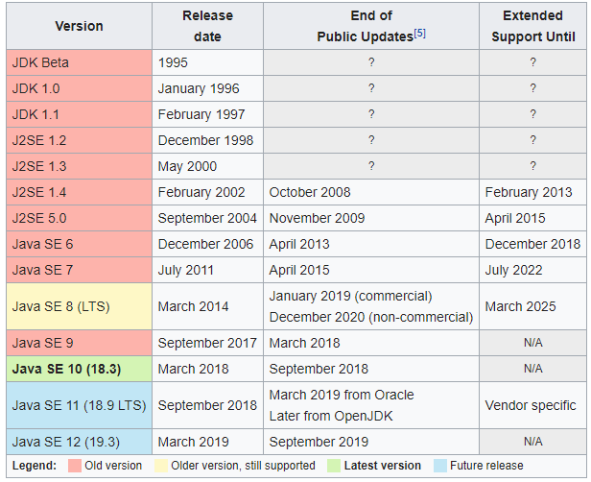

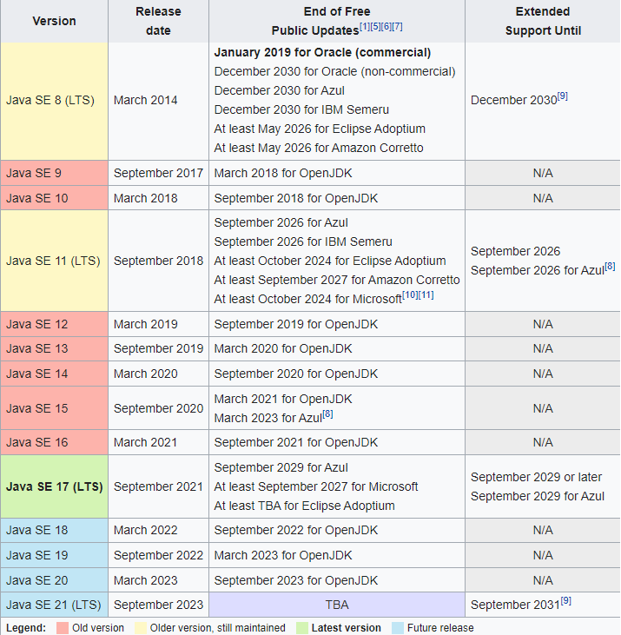

**Java 8** was released on 18th March 2014. That’s a long time ago but still many projects are running on Java 8. It’s because it was a major release with a lot of new features. Let’s look at all the exciting and major features of Java 8 with example code.

Some of the important Java 8 features are;

1. forEach() method in Iterable interface
2. default and static methods in Interfaces
3. Functional Interfaces and Lambda Expressions
4. Java Stream API for Bulk Data Operations on Collections
5. Java Time API
6. Collection API improvements
7. Concurrency API improvements
8. Java IO improvements